**Olympics History (1896 - 2016)**

**Data Set Overview:-**

Olympics history is given from 1896 – 2016 with all details of events, players, country and medals according to season (Summer and Winter). Problem statement is to perform ETL operation and meet the following analysis goals for this dataset.

**Goals Statements:-**

1. Extracting the raw dataset, performing cleaning, partition, transformations and analytical operations.
2. Creating Widgets for analysis.
3. Analysing aggregations on Medals
   * 1. Medals won by player.
     2. Medals won in a particular Sport.
     3. Medals won in Year.
     4. Medals won by Country.
4. Top 3 Players with MAX medal.
5. Country Participation in Olympic over Year.
6. Event Participation over Year.
7. Ratio of Athletes Participation by gender over Year.
8. Year wise Sport Analysis.
   * 1. Sport played over year.
     2. Sport First Played, Last Played in which year.
9. Newest Sport in Olympics.
10. Rank of country on the basis of medals.
11. Comparison b/w country over medals.

**Languages Used:-**

Python and SQL

1. Extracting the raw dataset, performing cleaning, partition, transformations and analytical operations.

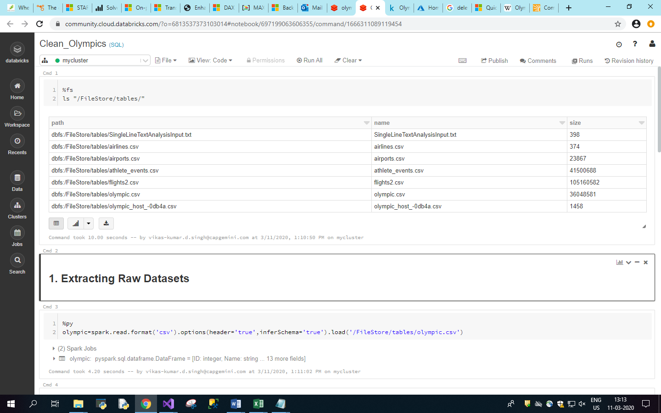

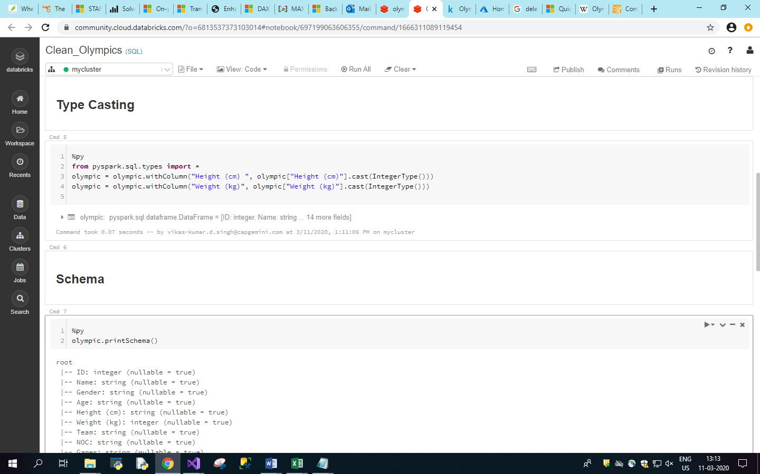

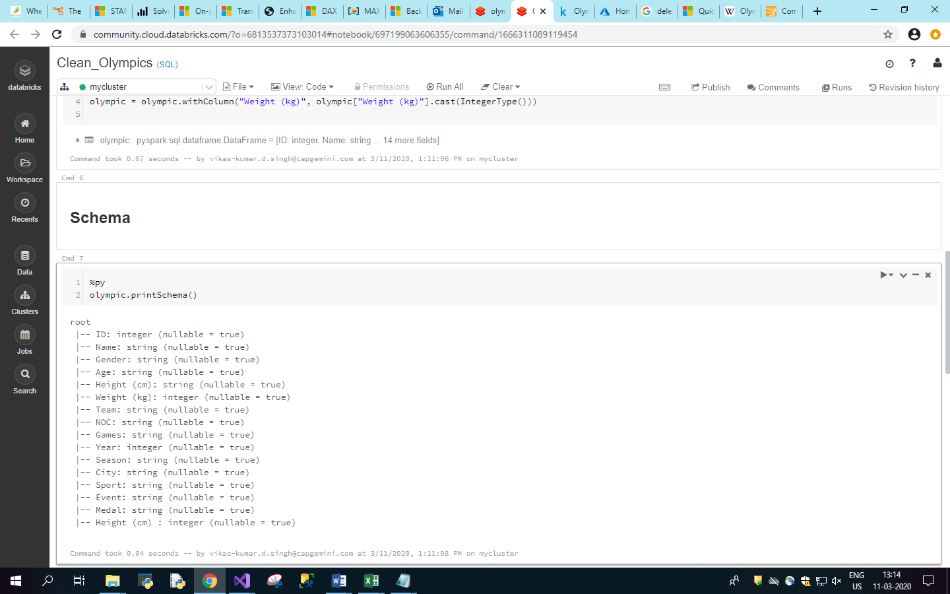

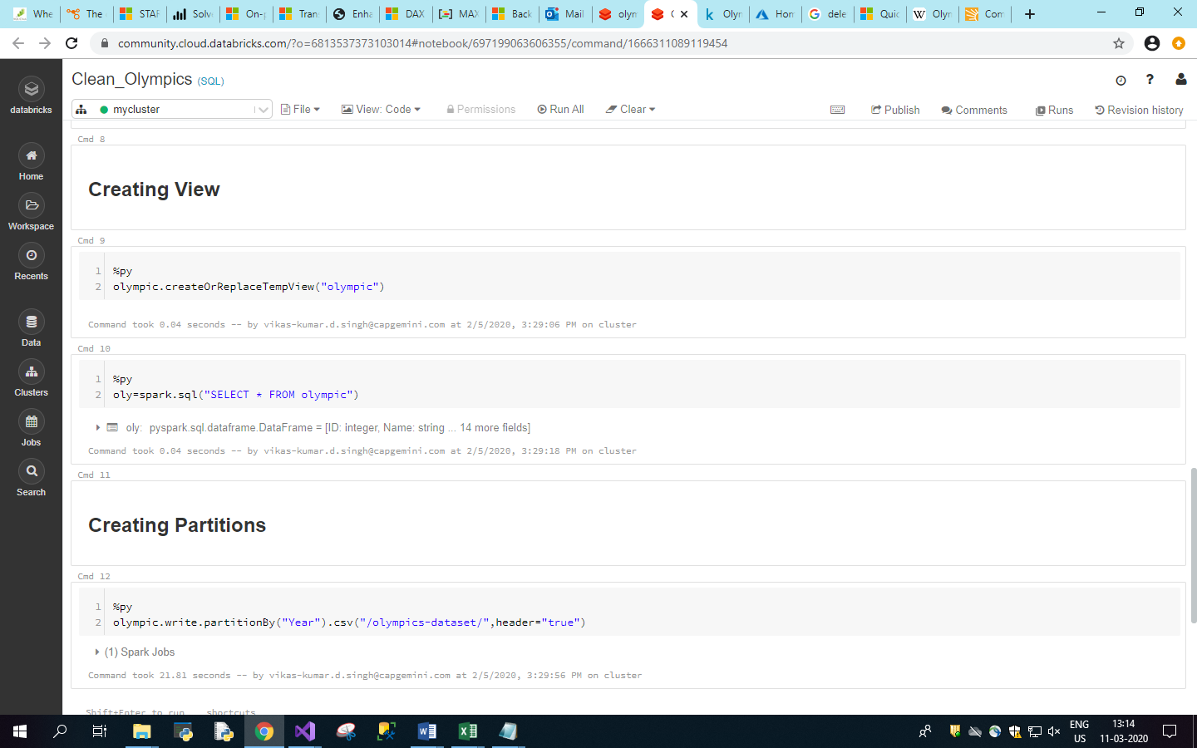

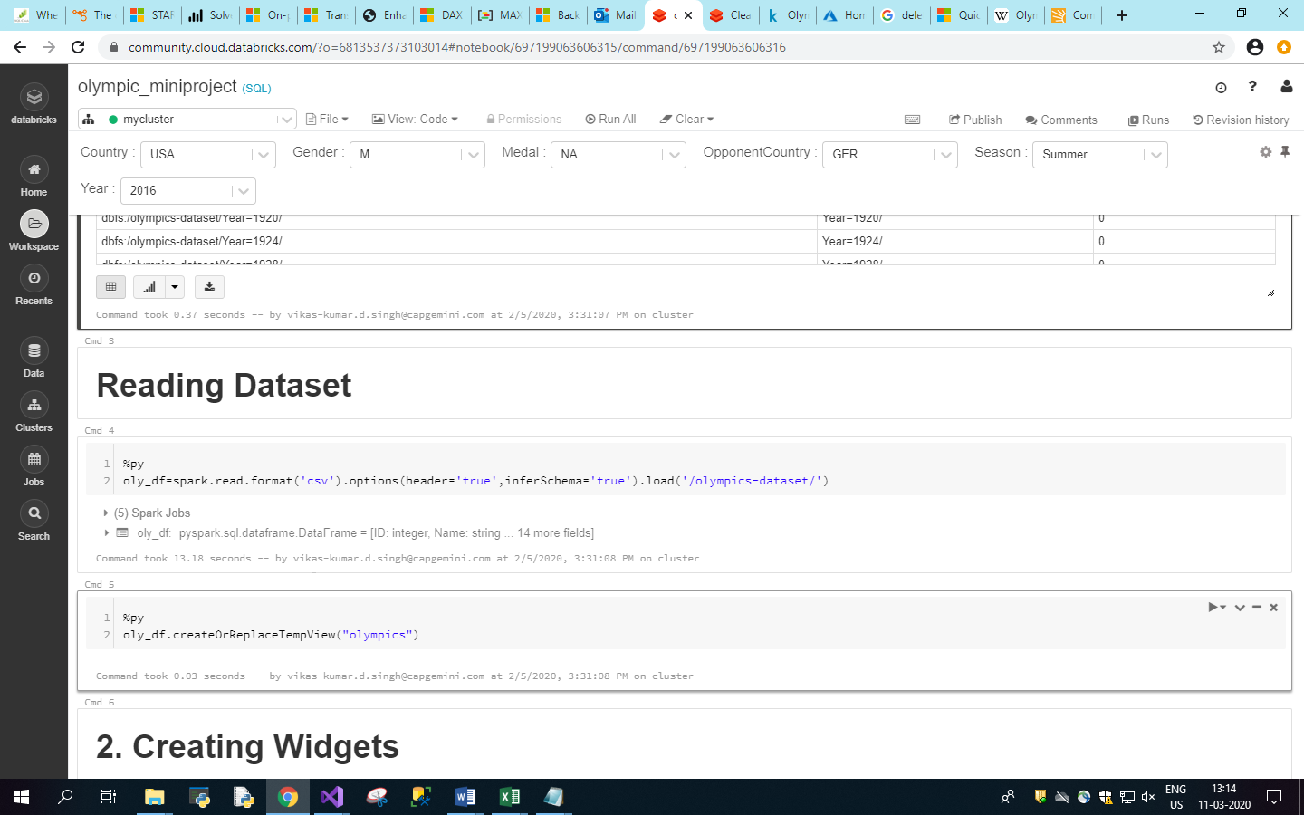

2. Creating Widgets

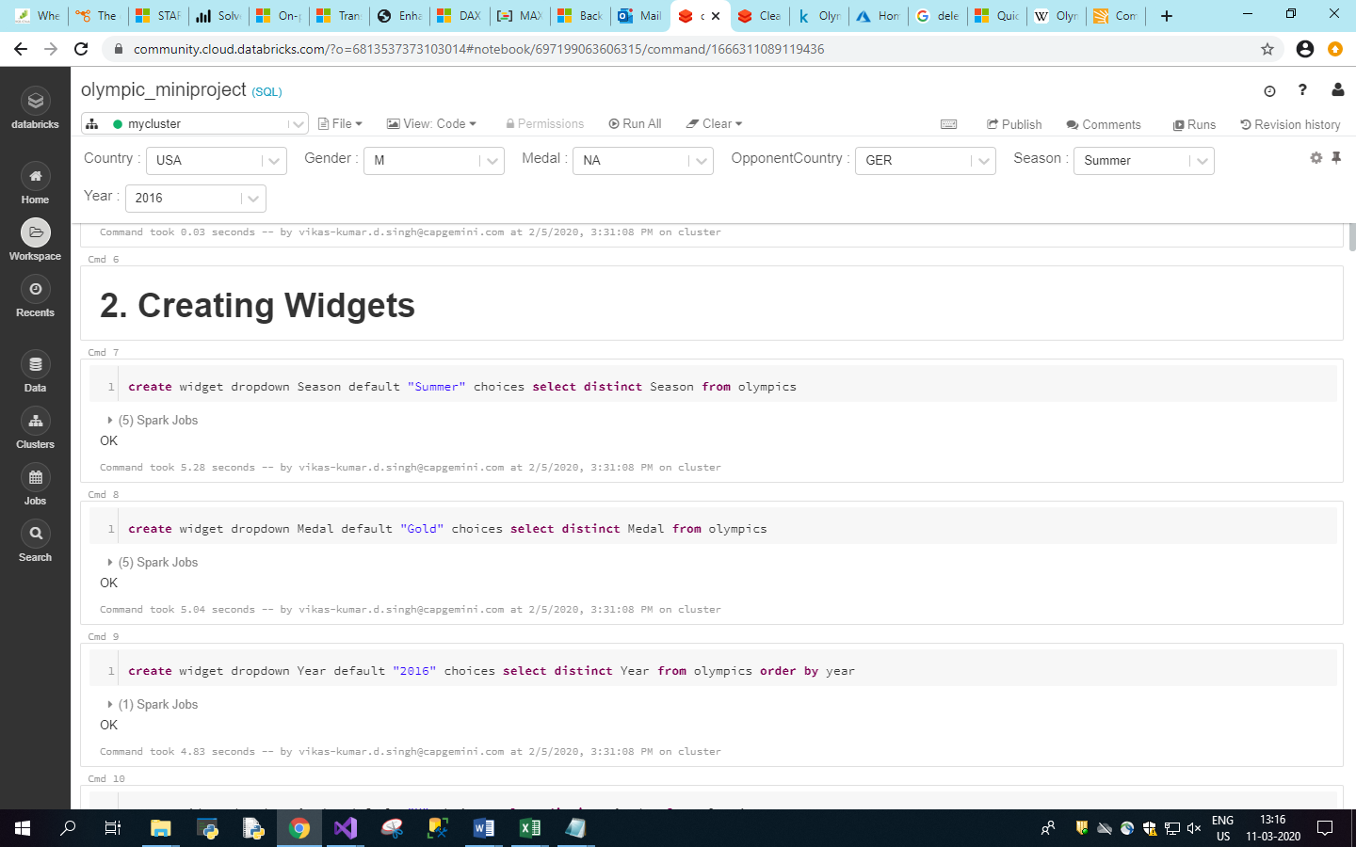

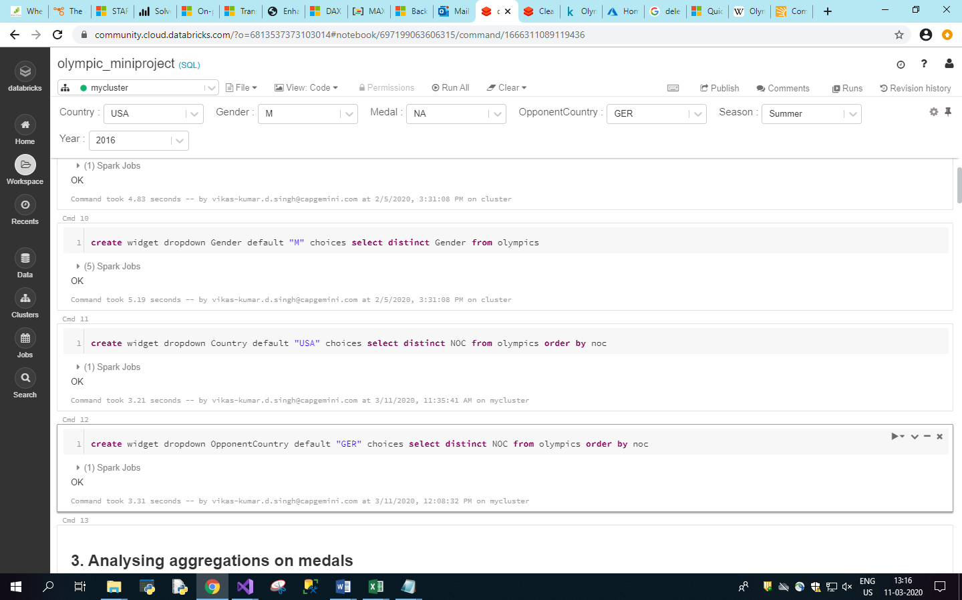

1. Analysing aggregations on Medals

Medals won by player.

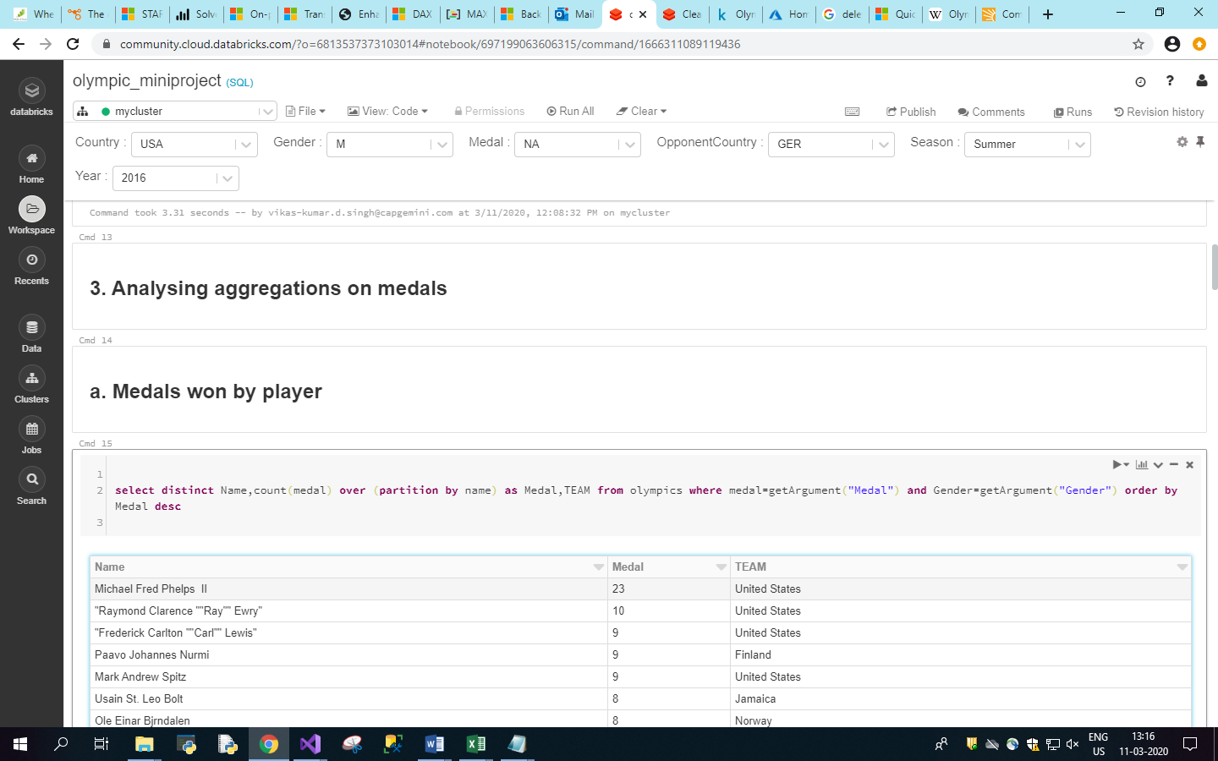

Medals won in a particular Sport.

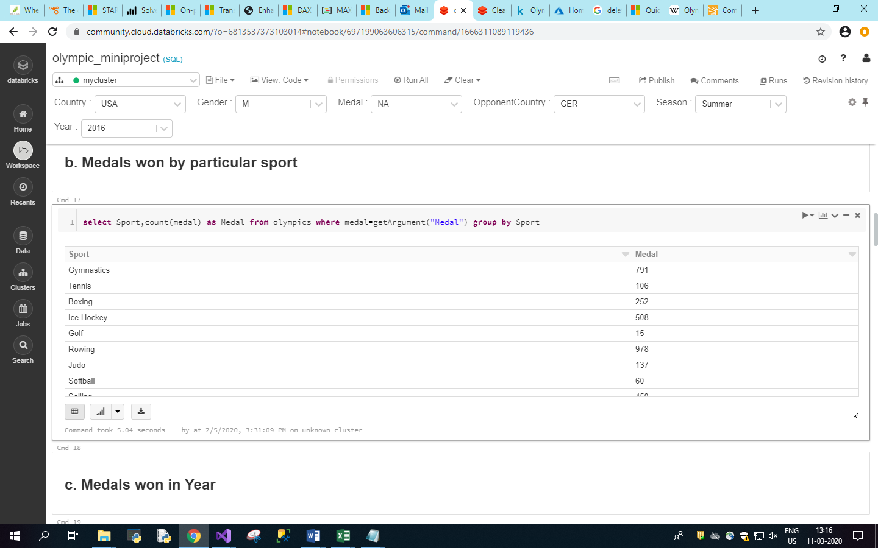

Medals won in Year.

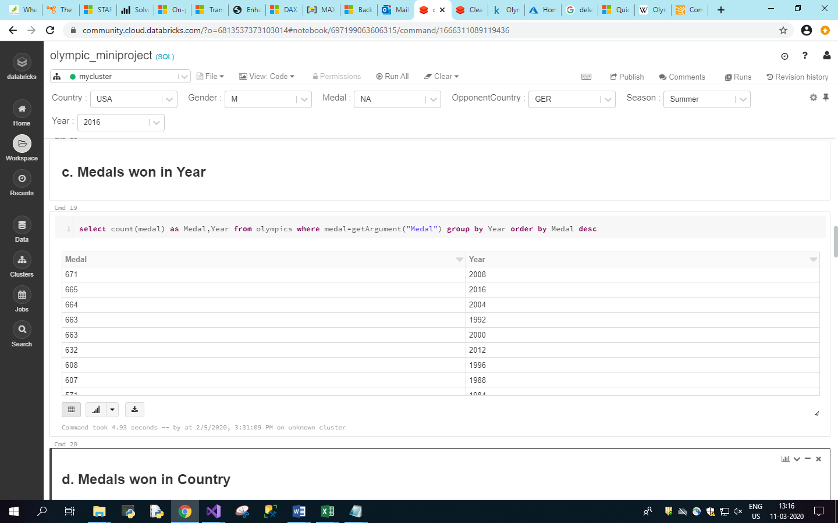

Medals won by Country.

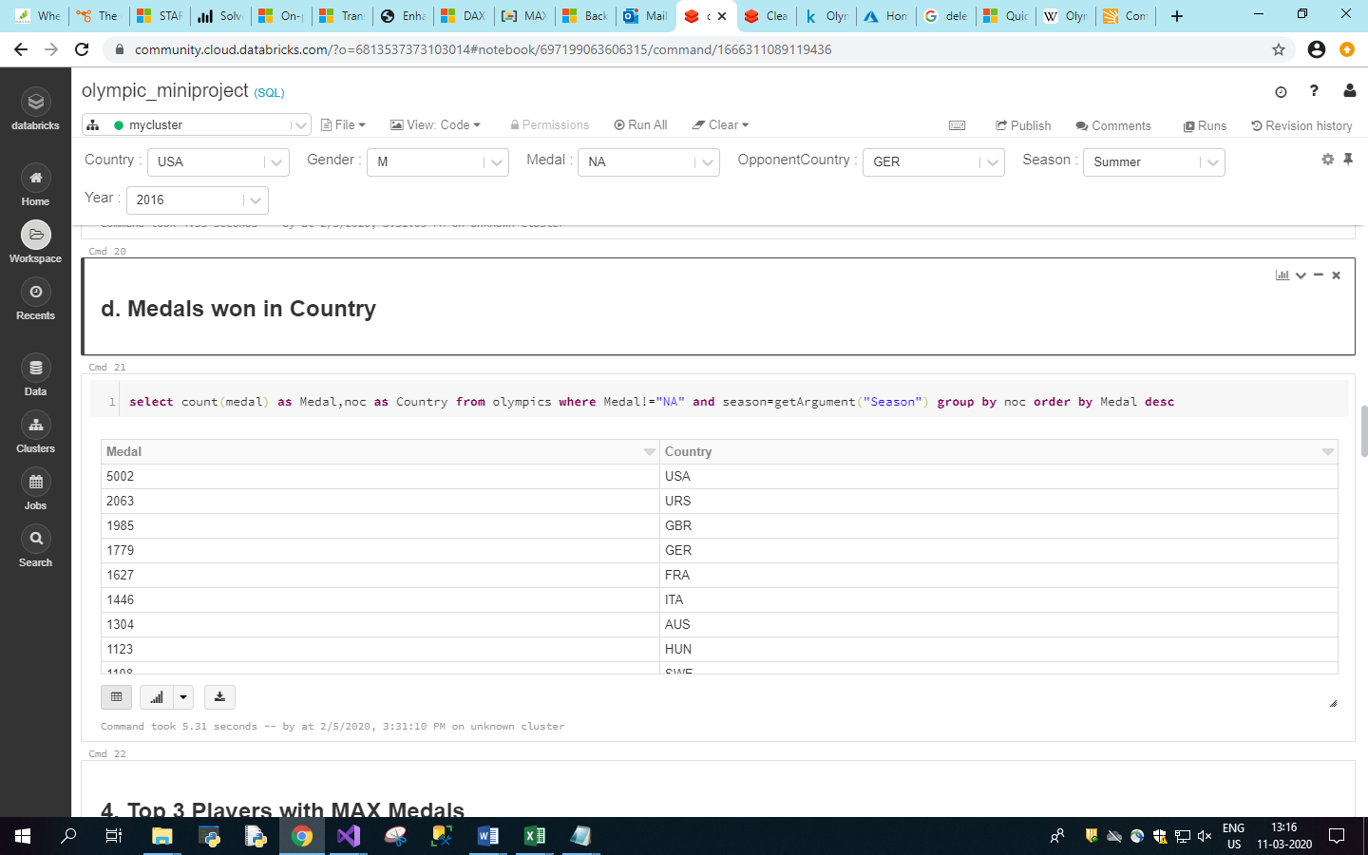

1. Top 3 Players with MAX medal.

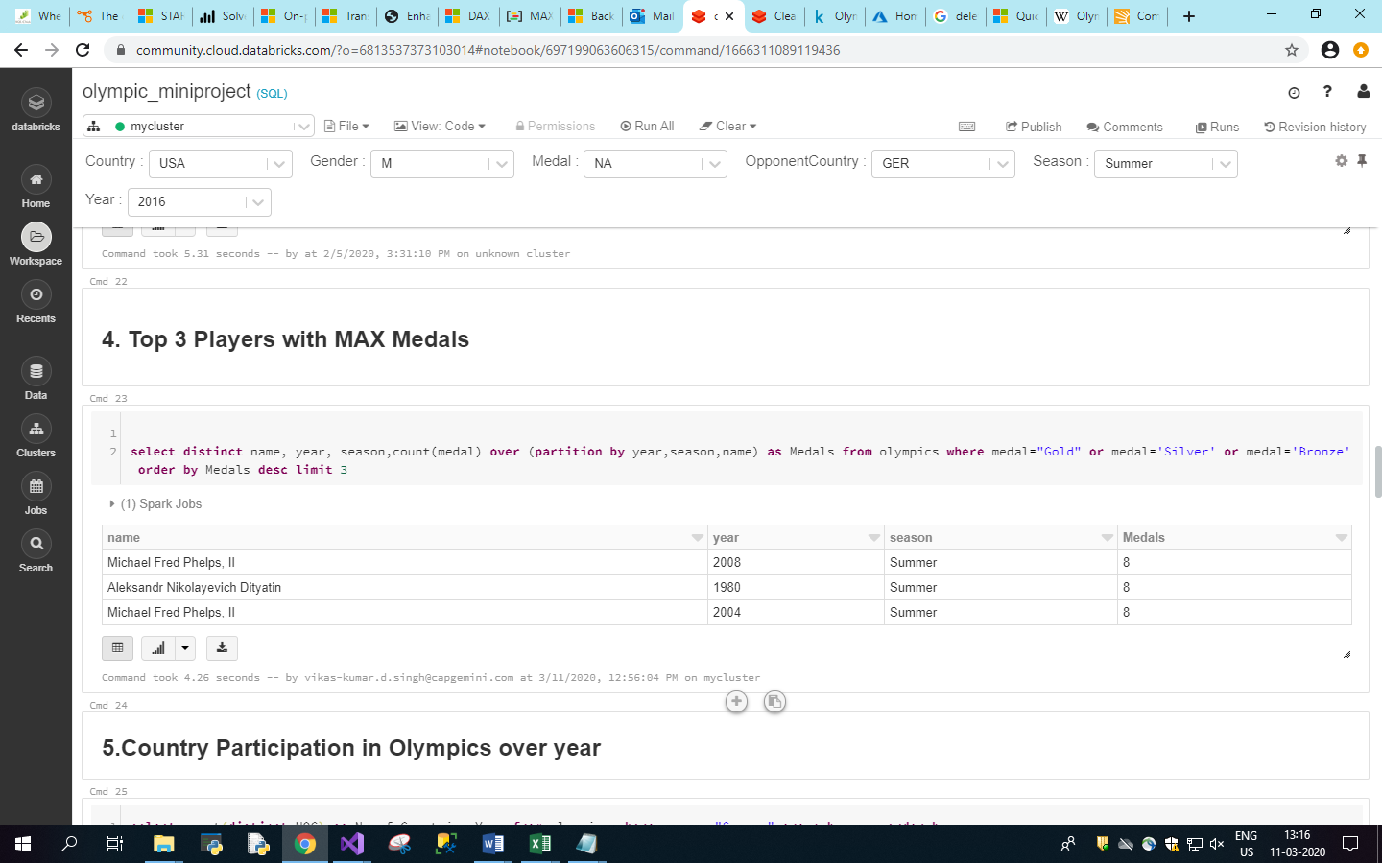

1. Country Participation in Olympic over Year.

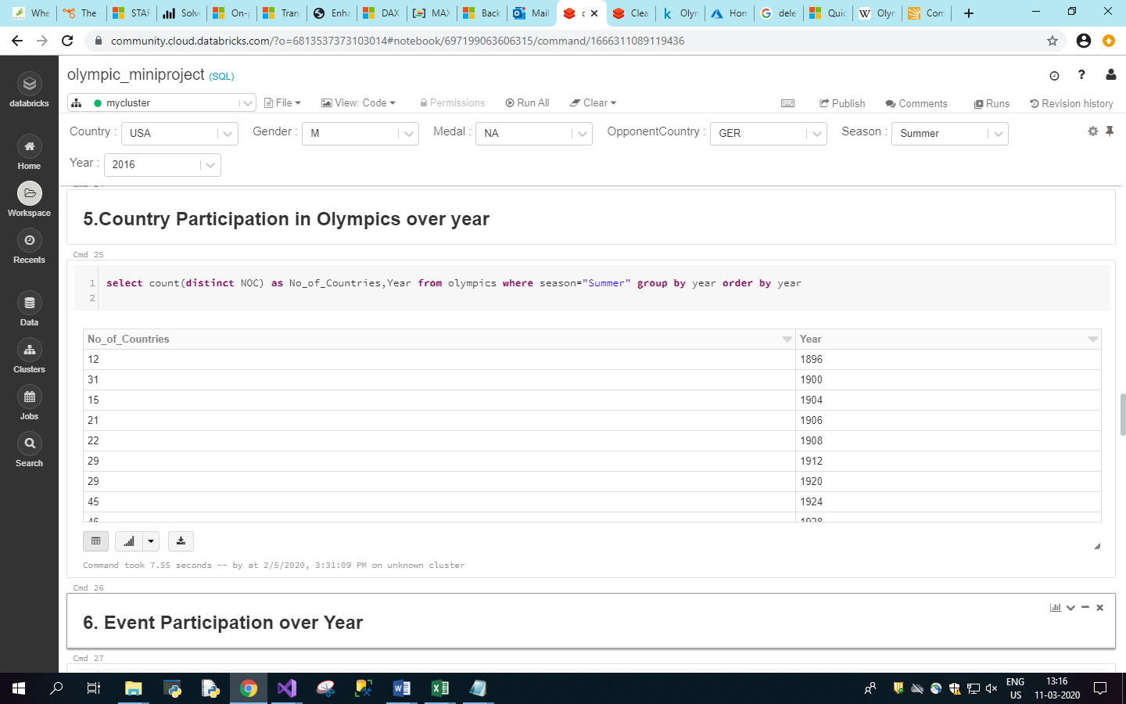

1. Event Participation over Year.

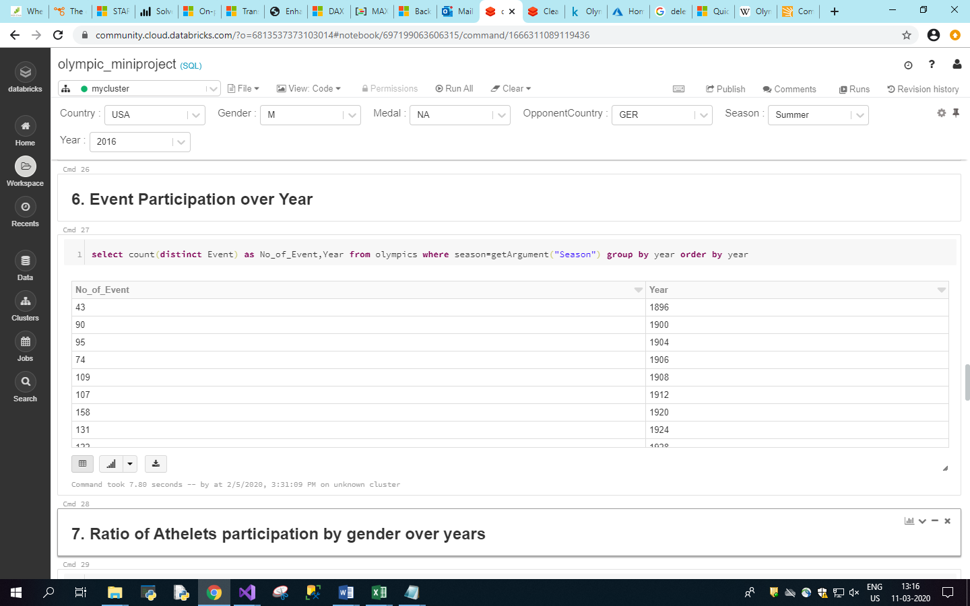

1. Ratio of Athletes Participation by gender over Year.

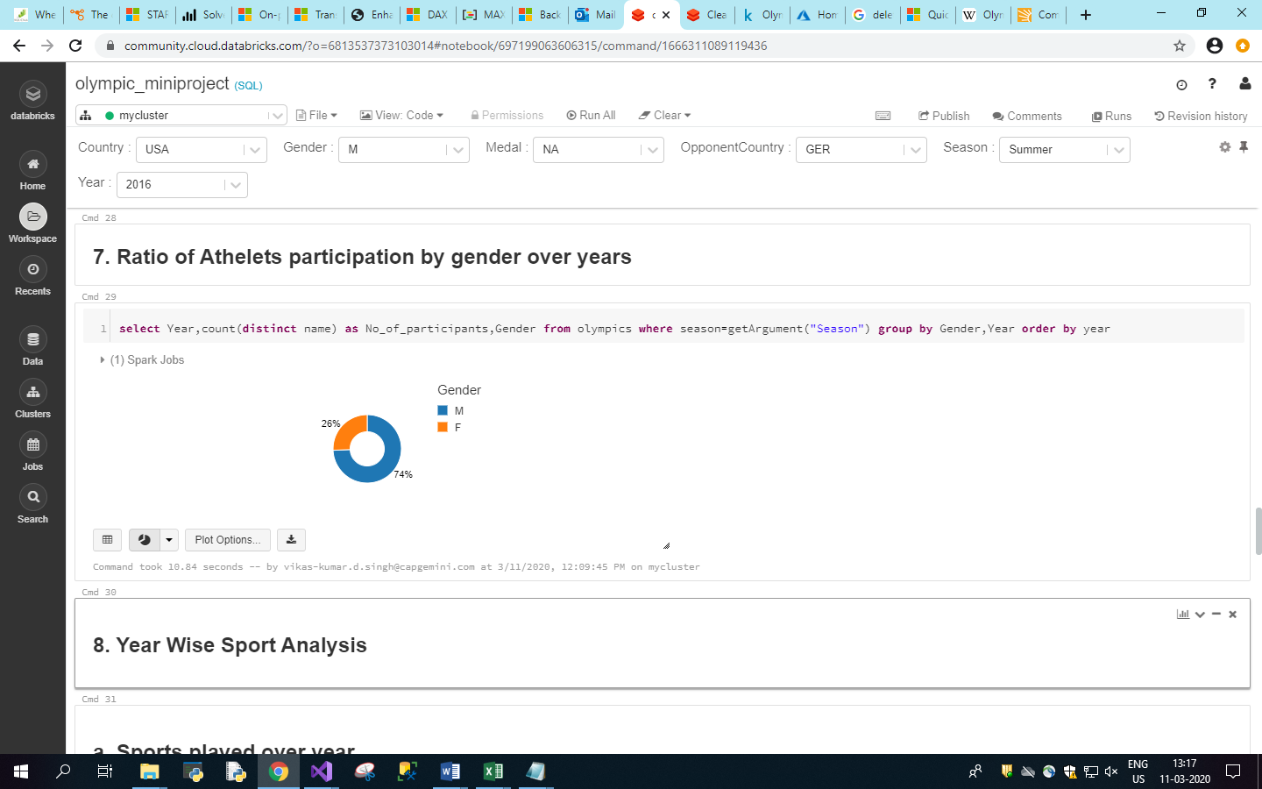

1. Year wise Sport Analysis.

Sport played over year.

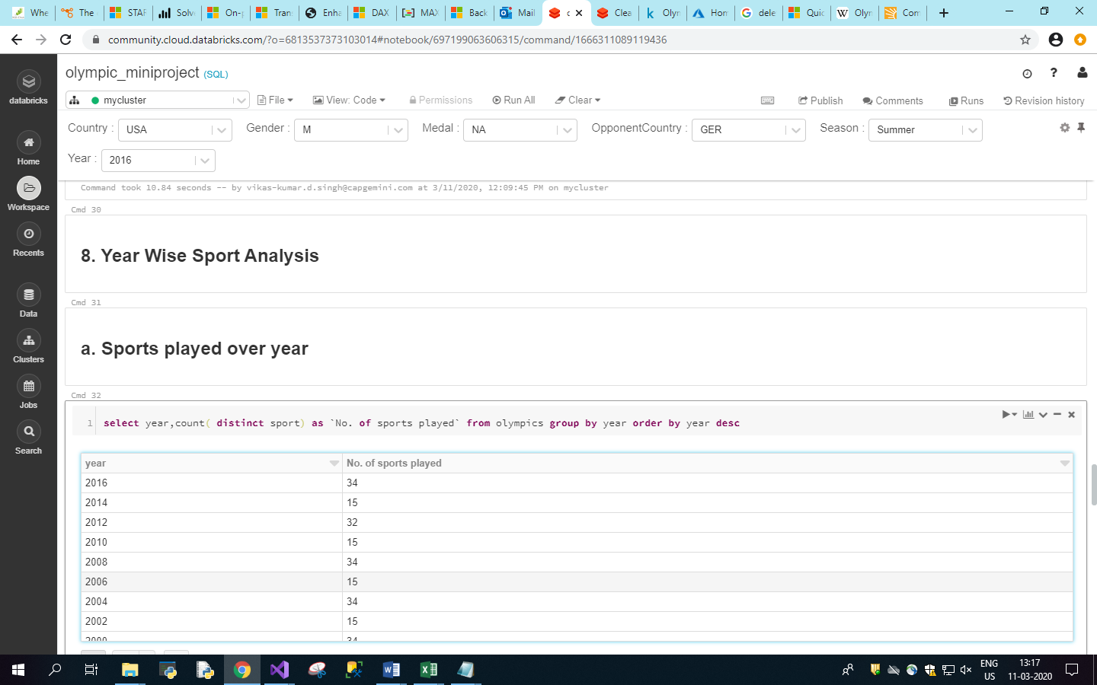

1. Sport First Played, Last Played in which year.

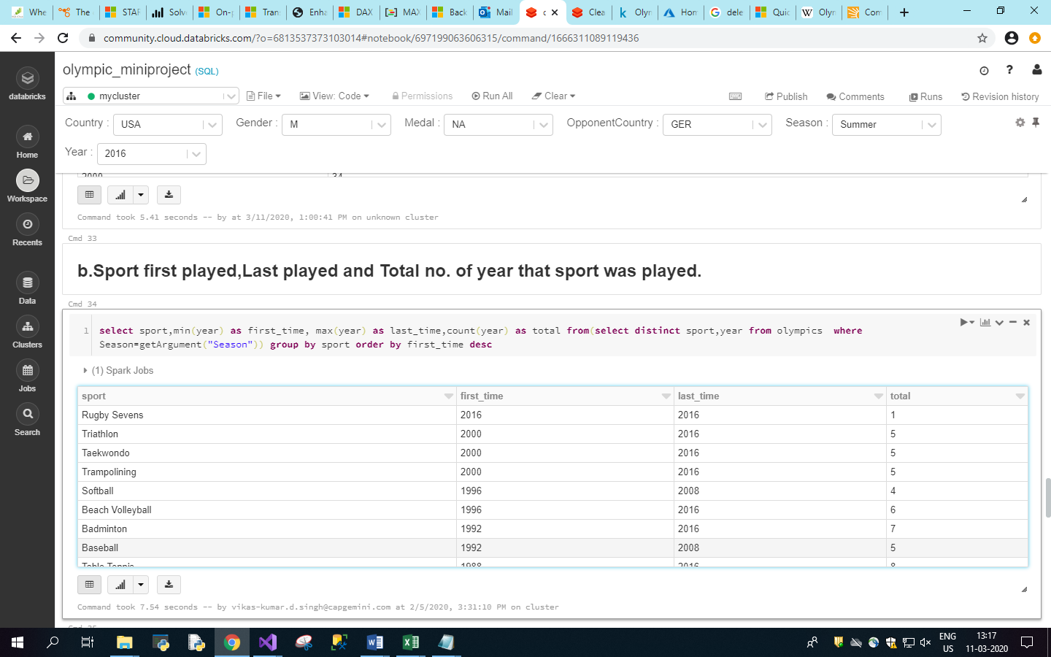

1. Newest Sport in Olympics.

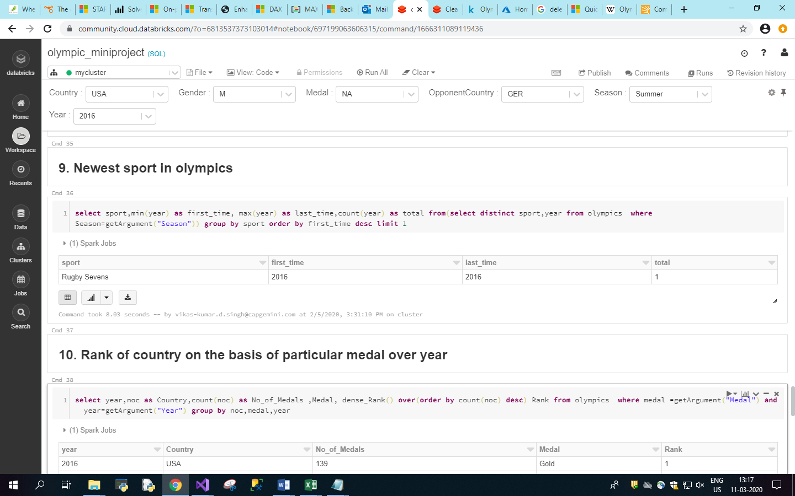

1. Rank of country on the basis of medals.

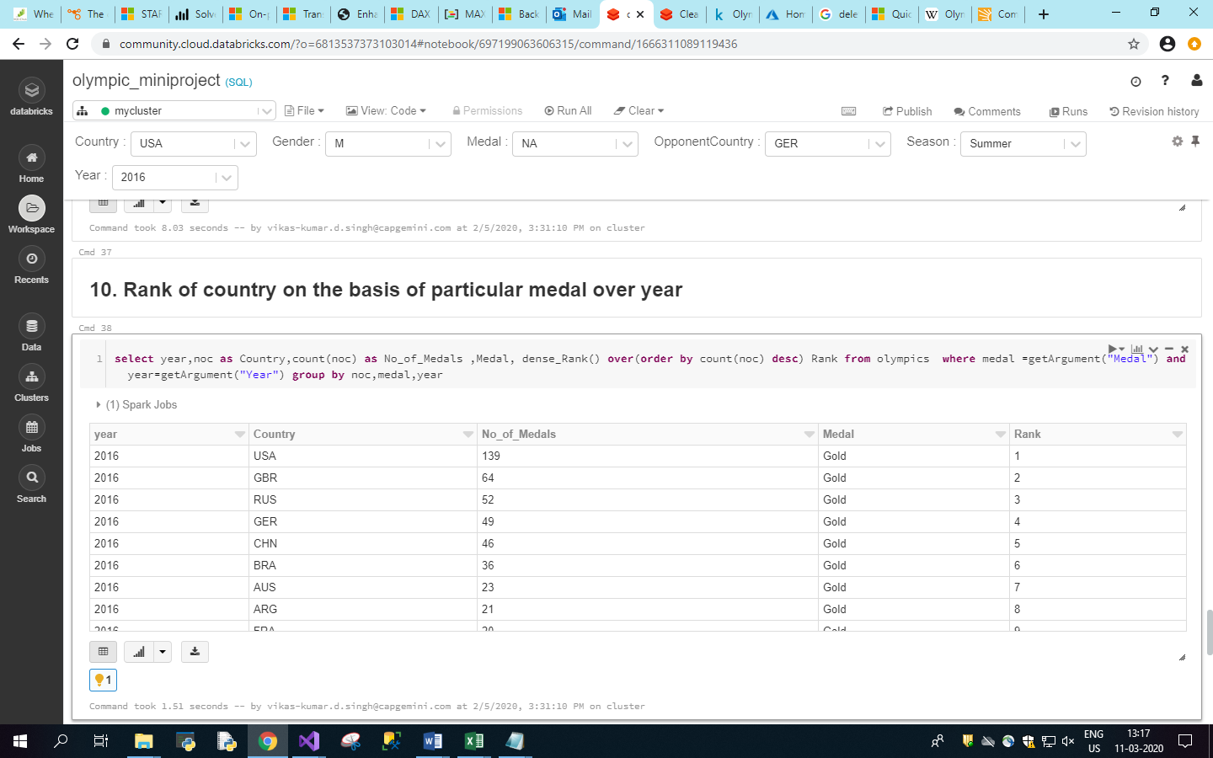

1. Comparison b/w country over medals.

